🔥 Day 25 — Combined Failure Lab
🎯 Goal
👉 Multiple issues at once
👉 You must NOT panic
👉 You must isolate layer by layer

💥 Step 1 — BREAK EVERYTHING (Controlled Chaos)
Do ALL of these:

1️⃣ Break DNS
sudo vi /etc/resolv.conf
Put:
nameserver 192.168.1.200
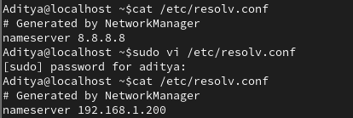

2️⃣ Break Routing (NAT path)
sudo ip route del default

3️⃣ Block Web Traffic
sudo iptables -A OUTPUT -p tcp --dport 80 -j DROP
sudo iptables -A OUTPUT -p tcp --dport 443 -j DROP
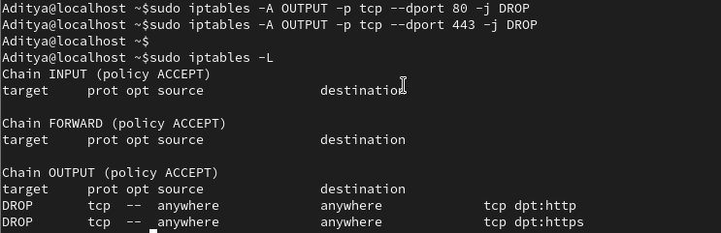

🧪 Step 2 — Observe
Run:
ping google.com
curl google.com
ping 8.8.8.8
👉 Everything should be broken / weird

🧠 Step 3 — DEBUG (THIS IS THE TEST)
You must follow strict order:

1️⃣ Check IP
ip a
✔ IP present → VM alive
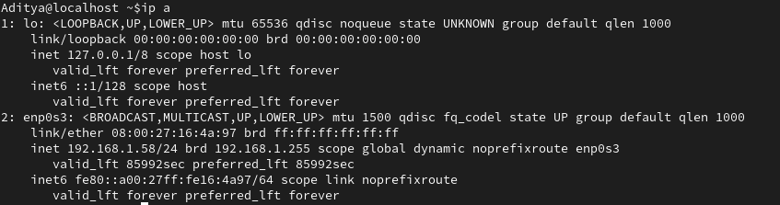

2️⃣ Check Gateway
ip route
❌ No default route → FOUND ISSUE #1

🔧 Fix routing FIRST
sudo ip route add default via 192.168.1.1
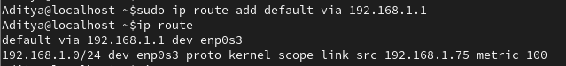

3️⃣ Test Internet IP
ping 8.8.8.8
✔ Works → routing/NAT fixed
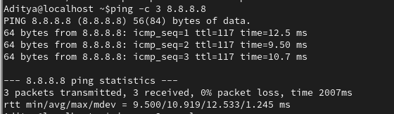

4️⃣ Test Domain
ping google.com
❌ Fails → DNS issue

5️⃣ Check DNS config
cat /etc/resolv.conf
👉 Wrong DNS → FOUND ISSUE #2
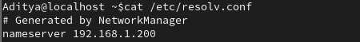

🔧 Fix DNS
nameserver 8.8.8.8
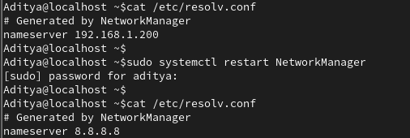

6️⃣ Test again
ping google.com
✔ Works
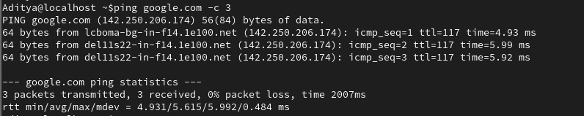

7️⃣ Now test website
curl google.com
❌ Still fails → WHY?

8️⃣ Check firewall
sudo iptables -L
👉 FOUND ISSUE #3
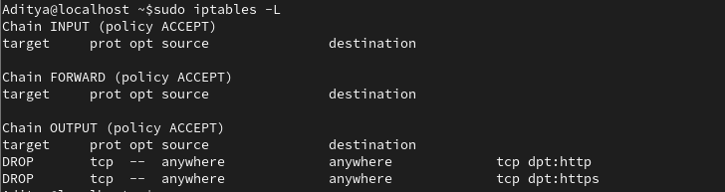

🔧 Fix firewall
sudo iptables -D OUTPUT -p tcp --dport 80 -j DROP
sudo iptables -D OUTPUT -p tcp --dport 443 -j DROP
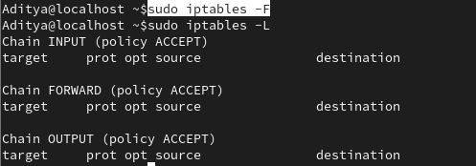

9️⃣ Final test
curl google.com
✔ FULLY WORKING
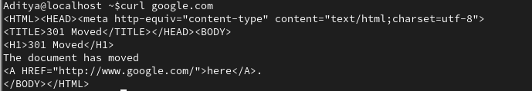

🧠 What You Must Write Today
Full Debug Flow (Final Form)
1. Check IP (ip a)
2. Check route (ip route)
3. Ping gateway
4. Ping internet IP
5. Check DNS (resolv.conf)
6. Test domain
7. Check firewall (iptables)

Key Insight
Multiple issues can exist at the same time.
Fix in order — not randomly.

Real Engineer Thinking
Layer 1: Network
Layer 2: Routing/NAT
Layer 3: DNS
Layer 4: Application
Layer 5: Firewall

✅ Expected Output (Day 25)
You should have:
✔ Broken 3 layers (DNS + NAT + firewall)
✔ Fixed them in correct order
✔ Understood layered troubleshooting
✔ Written full debug workflow

🔬 Lab Notes: Day 25 — Combined Failure Lab
🎯 Objective
To master layered troubleshooting by intentionally breaking and then fixing multiple network layers (DNS, Routing, and Firewall) in a specific, logical order (pp. 1, 6).
🛠 Phase 1: The "Break" (Controlled Chaos)
To simulate a total network failure, the following layers were disabled (pp. 1-2):
- DNS: Misconfigured /etc/resolv.conf to a non-existent nameserver (192.168.1.200).
- Routing: Deleted the default gateway using sudo ip route del default.
- Firewall: Blocked all outgoing web traffic (HTTP/HTTPS) using iptables DROP rules.

🧠 Phase 2: The Debug Flow (Final Form)
The key insight is to fix the foundation before the roof. You cannot test DNS if your routing is broken.
Order | Action | Command | Purpose
1 | Check IP | ip a | Confirm the VM is alive and has an interface IP (p. 2).
2 | Check Route | ip route | Identify missing default gateway (p. 2).
3 | Fix Routing | sudo ip route add default via 192.168.1.1 | Restore the NAT path to the internet (p. 3).
4 | Test IP Ping | ping 8.8.8.8 | Verify raw connectivity (Routing/NAT is now fixed) (p. 3).
5 | Check DNS | cat /etc/resolv.conf | Verify if domain resolution is correctly pointed (p. 3).
6 | Fix DNS | sudo systemctl restart NetworkManager | Restore working nameserver (e.g., 8.8.8.8) (p. 4).
7 | Test Domain | ping google.com | Verify DNS resolution is working (p. 4).
8 | Check Firewall | sudo iptables -L | Identify DROP rules blocking ports 80 and 443 (p. 4).
9 | Fix Firewall | sudo iptables -F | Flush/Clear rules to allow web traffic (p. 5).
10 | Final Test | curl google.com | Full application-layer success (p. 5).

💡 Key Learning: Real Engineer Thinking
In production, issues rarely come one at a time. This lab proves that you must follow the OSI-style Layered Approach (p. 6):
- Layer 1-2: Network/Interface (Is the cable/link up?)
- Layer 3: Routing/NAT (Can I talk to the outside world?)
- Layer 4: DNS (Can I translate names to IPs?)
- Layer 5+: Application/Firewall (Is the specific service allowed?)
Rule of Thumb: Fix in order—never randomly. If you fix the firewall but the route is still missing, curl will still fail.

